
Oregon State University Faculty Senate

2024 – 2025 Annual Report
Core Education Committee

Introduction
The Core Education Committee (CEC) sets the strategy, policy, and plan for the General Education program. The primary work of the Committee is to review requests to include courses in the various categories of the General Education program. Additional work involves the development of policy and planning for the future of the Core program. This committee has a key shared governance role in coordinating with various administrative offices in Academic Affairs, Student Affairs, Athletics and beyond as it relates to the Core program.

Meeting Cadence and Member Workload
During AY24-25, we held weekly meetings for two hours (returning to one hour for AY25-26). Committee members are typically assigned 1-2 courses for review weekly (in normal years, 1-2 courses a month). Further reviews on resubmissions of the same course are assigned to the same members. Members may also be assigned policy documents for review. At peak workload during Winter of 25, workload reached 3-4 course reviews per week per committee member including reviews of resubmissions. During a typical service year, the average workload is two hours per week, with the heaviest workload in February/March as the Category Review process is being completed, which coincides with the catalog deadline.

Standing Rules
The Core Education Committee has the authority to develop and approve strategy, policy and planning for the Baccalaureate Core/Core Education programs.

The Committee reviews the content and appropriateness of both existing and proposed Baccalaureate Core/Core Education courses. The committee shall conduct periodic reviews of the overall Baccalaureate Core/Core Education programs, and of existing courses within these programs, to ensure that the criteria of the general education model are being met and to evaluate student attainment of category learning outcomes. This work depends on the availability of data to be provided by university administration at the request of the Committee. The Committee shall also evaluate proposals for additional and new courses deemed relevant to the core and stimulate proposals for additional and new courses as deemed necessary and advise faculty members in the preparation of such proposals.

The Committee shall consist of fourteen voting faculty, at least thirteen of whom shall be teaching faculty, and two voting students. In so far as possible, at least two of the voting faculty shall be from the College of Liberal Arts, at least two from the College of Science, at least one from each college responsible for granting standalone baccalaureate degrees, at least one from OSU-Cascades, and one professional academic advisor. The following shall be ex-officio, non-voting members: the Director of Core Education, the Writing Intensive Curriculum Program Director, the Difference, Power, and Oppression Program Director, two representatives appointed by the Vice Provost for Academic Affairs with specialties in general education assessment and curriculum management, and an Ecampus representative appointed by the Vice Provost, Division of Educational Ventures.

Voting quorum consists of a majority of the voting committee members.

Course Selection

- The Committee may solicit courses, which include detailed descriptions and outlines, from all colleges/departments.
- All existing, modified and new courses proposed by individual faculty, groups of faculty, or departments for inclusion in Core Education must be approved by an appropriate faculty curriculum committee within the college of origin prior to submission to the Committee.
- All submissions shall be routed for additional curriculum review at the discretion of the Committee. Request for such reviews, and selection of the reviewing unit, will be made by the Committee. The criteria used to select the reviewing unit will be based upon that unit's ability to assess the proposed Core Education objectives.
- All submissions pertaining to Writing Foundation and Writing Elevation must be routed to the Writing Advisory Board, which is composed of the Writing Intensive Curriculum Director, the Director of First Year Writing, the Director of the Writing Center, and a writing faculty member with expertise in technical and professional writing. This Board will consult with faculty to develop and implement proposals that meet Core Education criteria.
- The Committee will review all submissions to assure compliance with the criteria adopted by the Faculty Senate; those courses which are deemed by the Committee to meet these criteria and address the category learning outcomes can be approved for inclusion as Core Education courses, subject to approval by the Curriculum Council.
- The Committee has the authority to request changes to existing courses and/or deny continuation of Baccalaureate Core/Core Education status for courses.

Category Reviews

- The Committee will periodically request and review institutional data in order to evaluate Baccalaureate Core/Core Education categories based on:
- adequate access to courses within the category;
- consistency of category criteria and learning outcomes with institutional goals for undergraduate learning;
- evidence of students achieving satisfactory success relative to category learning outcomes; and
- continued satisfaction of category criteria by individual courses.
- The Committee has the authority to request changes to existing courses and/or deny continuation of Baccalaureate Core/Core Education status for courses.

Changes in Core or Criteria or Process

- Any changes in the Baccalaureate Core, Core Education, the supporting criteria or the process will require the approval of the Faculty Senate.

(12/14)

Summary of 2024 – 2025 Work
The Committee made decisions on 529 course reviews and 6 policy proposals over 36 meetings, with 353 approvals. Many courses require modification to meet the categories. The specific detail of that follows:

Review Time | Action | Number
First | Approve | 245
First | Rollback | 132
First | Defer | 3
First | Hold | 1
First | Move Forward | 4
Second | Approve | 80
Second | Rollback | 34
Second | Defer | 2
Third | Approve | 23
Third | Rollback | 4
Third | Defer | 1
Fourth | Approve | 5
Courses not continuing after first rollback. Of the 132 courses rolled back for revisions after first review, 108 went on to be approved after revisions, meaning that only 24 out of 380 courses reviewed by the committee (6%) were dropped after feedback and not resubmitted. 94% of courses submitted to the Core this year were eventually approved, although many required multiple rounds of feedback and revisions prior to approval. The primary reason for courses not continuing on to final approval was that they were not appropriate for the category. A handful of the non-continuing courses required a complete overhaul and may be seen in the 25-26 academic year (such as BA 251) or a late-breaking proposal (DS 201).

Courses rolled back multiple times. Among the courses which were rolled back multiple times, the Core Education Director noted that several of those were by proposers who had been given waivers on Core Education training (such as waivers on Difference, Power & Oppression (DPO) training), had arrived late/left early from trainings, or otherwise did not take training seriously.

Approval rates by category:
Category | First Review Approvals | Total Approvals | Percentage Requiring Revision
Arts & Humanities - General | 28 | 31 | 10%
Arts & Humanities - Global | 25 | 29 | 14%
Beyond 1 | 20 | 28 | 29%
Beyond 1+2 | 28 | 30 | 7%
Beyond 2 | 27 | 36 | 25%
WIC + Beyond2 | 5 | 7 | 29%
DPO-Foundations (F) | 18 | 38 | 53%
DPO-Advanced (A) | 22 | 43 | 49%
Quantitative Literacy | 1 | 6 | 83%
Communication, Media, Society | 1 | 5 | 80%
Scientific Inquiry | 23 | 36 | 36%
Seeking Solutions | 14 | 22 | 36%
Social Science | 10 | 17 | 41%
Transitions | 10 | 12 | 17%
WIC | 9 | 10 | 10%
Writing Elevation | 4 | 5 | 20%

The highest revision request rates were in the former “skills” categories (e.g., Quantitative Literacy; Communication, Media, Society), which were previously provided under the Baccalaureate Core by the Speech and Math departments as a service to the University. Historically, in these “locked” categories the learning outcomes were vague and there was an expectation that these recognized experts would deliver the materials. Those units may not have developed skills for the competitive marketplace of inter-college space and rigorous reviews of proposals. New entrants into these spaces were also a key factor in high rollback rates, as it was a common issue that new entrants did not read the Learning Outcome, Criteria & Rationale (LOCR) document carefully and, for example, would submit Communication, Media, and Society courses without the required speeches.

The DPO categories have particularly intense outcomes and criteria which required additional attention, resulting in above average revision request rates for those categories as well.

Some categories were discussed at particular times, those patterns can be visualized:

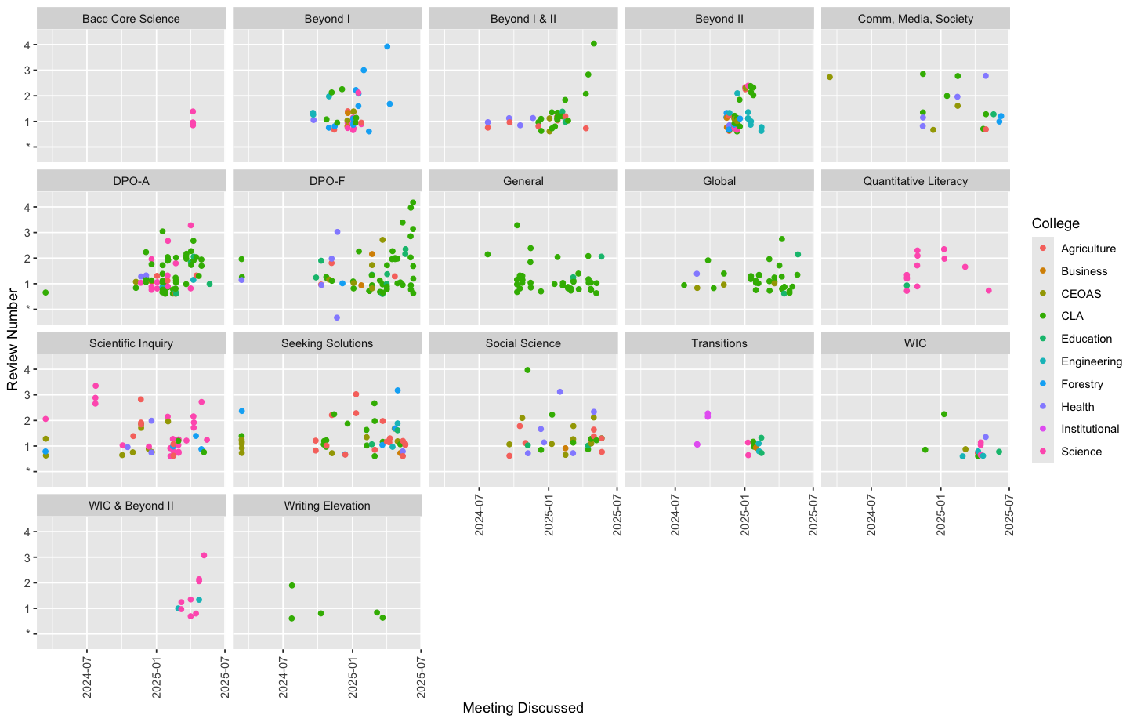
This is best viewed on a larger screen. The patterns in the timing of our work can be seen in each category. In Fall/Winter, we focused on items required for category proposals (e.g., Beyond and DPO-A) before turning to general areas. In early Winter, it appeared that there would be shortages in the Humanities categories; this was quickly resolved in late Winter by focusing committee review time on these categories. The LOCR for the Humanities categories are clear and unambiguous and the proposals were often developed by traditional humanities units, which made many of these easy reviews with relatively few rollbacks for revisions required. It is also notable that there are additional rollbacks (and multiple rollbacks) for courses near the end of the year. We prioritized the order of course reviews by category need, and after high need categories were addressed, we then ordered reviews by the arrival date of courses into our queue. Some late arriving courses had significant issues which required additional revision.

We note that courses being rolled back multiple times can be frustrating for proposers and proposing units. Generally, colleges saw about one-third of their proposals rolled back. The rates of rollbacks by college are:
College | Successful First Reviews | Total Success | Return Rate
Agriculture | 26 | 35 | 26%
Business | 9 | 13 | 30%
Earth, Ocean & Atmospheric Sciences (CEOAS) | 24 | 32 | 25%
Liberal Arts (CLA) | 101 | 154 | 34%
Engineering | 18 | 20 | 10%
Education | 8 | 14 | 43%
Forestry | 12 | 16 | 25%
Heath | 16 | 22 | 27%
Science | 31 | 49 | 37%

CLA has the largest scope of Core participation. However, it is important to note that this reflects that CLA has the largest academic programs portfolio: 55 of the 154 (35%) CLA course proposals for the Core are in Beyond OSU, DPOA, or WIC and are necessary for programmatic requirements. The rate of proposals that meet programmatic requirements (Beyond, DPOA, WIC) varies by college. A few examples include Health 45%, Science 57%, CEOAS 25%, Agriculture 33%. Generally, courses in the Beyond category had a high rate of first review passage, so a high percentage of these courses could make a college appear to be more successful on first review. This explains why Engineering had 90% initial review success – courses proposed by this college were primarily submitted to support their program proposals – Beyond, DPO-A, and WIC.

Mentorship for weak proposals. The co-chairs of the committee are often asked to provide substantial feedback for faculty. At times, proposers do not have a strong understanding of the Core category they are submitting to, requiring substantial mentorship by co-chairs or other committee members. We estimate that during AY24-25, the co-chairs spent an average of 2-3 hours per week providing feedback, guiding, and mentoring faculty proposers. This is not a trivial amount of time invested.

Review standards. Review standards for course proposals held closely to the LOCR document. All Learning Outcomes and Criteria had to be strictly met and assessed in any given proposal for the course to be approved by the committee. For these initial reviews, the committee evaluated courses strictly based of the learning outcomes and criteria for each Core category. The committee did not evaluate courses based on other factors such as whether or not the course was designed for general education, if it was being offered in the appropriate unit, or if it replicated content taught elsewhere. Questions of purpose (e.g. is the fundamental purpose if this course general education?) and audience (e.g., will this course enroll outside the major?) were deferred to the first round of compliance reviews to allow for data collection and to give units the benefit of the doubt on the prospect that courses which seem to be designed for a single major were in fact going to serve primarily as general education courses. Future committees will need to attend to this issue with data.

Reviewer assignment process. Every course is assigned two committee members to review it. Reviewers are assigned to courses outside their colleges. During the meeting, committee members share their reviews, and the committee discusses the course, including any concerns or perspectives raised by non-reviewing committee members. Members are welcome to participate in the discussion and vote on courses within their own colleges, although they will not be assigned as primary reviewers on these courses. Generally, members are not allowed to participate in the discussion of their own proposals. Per Oregon Open Meeting law, members are not precluded from being present during discussion of their proposals, but nearly all choose to be placed in a breakout room for reasons of collegiality.

Name and college | Number of times assigned
Dan Faltesek, CLA | 84
Kelsey Emard, CEOAS | 93
Liz Delf, CLA | 78
Andrea Allan, CEOAS | 84
Aidas Banaitis, Cascades/Science | 74
Matt Kennedy, Agriculture | 79
Kari-Lyn Sakuma, Health | 83
Abigail Crowell, Athletics | 76
Lori McGraw, Health | 84
Paula Weiss, Science | 77
Brian Mills, Engineering | 82
Holly Mitchell, Ed | 74
Vipin Arora, Business | 49
David Stemper, Forestry | 58

Courses were assigned for review more or less as they came in. Although this committee did meet over the summer (two meetings in U24, and is not meeting U25), proposals still have a tendency to accumulate. Later delays were a result of the co-chairs prioritizing high-need categories and re-reviews of rolled back classes. It is not optimal to assign reviews and then wait several weeks for discussion, it is better to assign fresh when review labor is available for dispatch. We can see the accumulation of reviews as more difficult cases were discussed in the spring though a comparison of assignment date to discussion date:
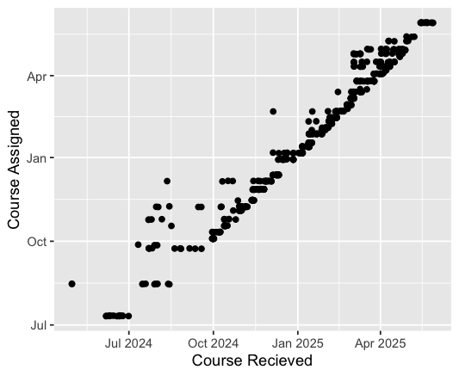

Category color added for visual and conceptual interest. The dots near the x-axis were a special case. Weekly progress rates varied due to meeting length (shorter in the fall), and the carry-over of proposals from week-to-week. We generally use a six-minute clock to reach an initial decision on any given proposal; more difficult decisions require “overtime."

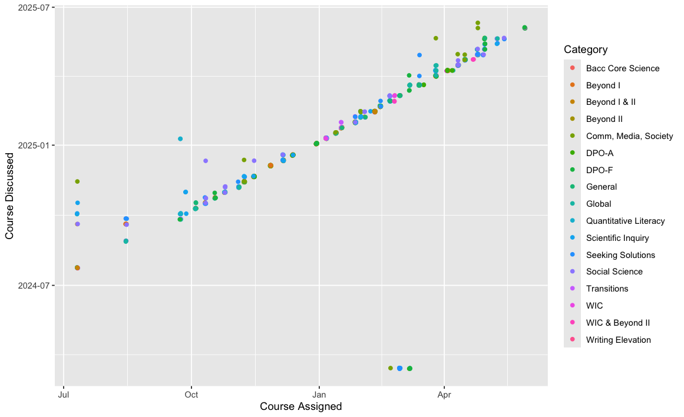

The number of courses discussed at each meeting during AY24-25 is listed in the following table. We increased the number of hours we met per week and implemented a number of efficient meeting strategies to move us through the large number of reviews necessary between November and May, which is reflected in the increased number of reviews beginning in our November meetings. The lower number of reviews at select meetings in March, April, and May are reflective of meetings where we had to discuss and vote on matters of policy. During AY 24-25, the committee made decisions and wrote policy pertaining to Transitions curriculum, math standards, future installation, assessment practices, and Beyond curriculum.
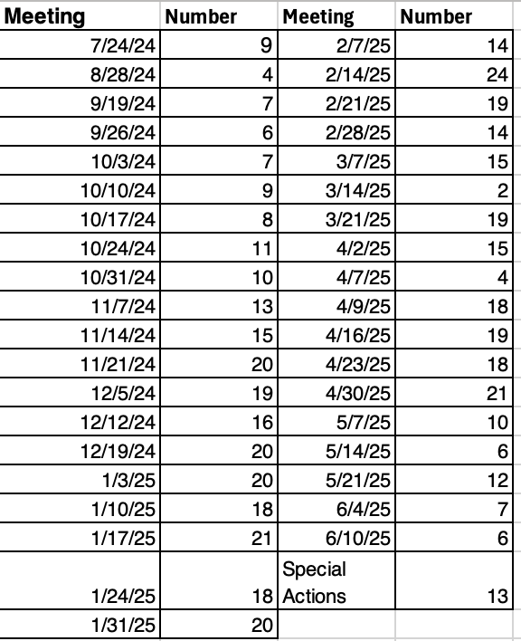

Preparation. On a weekly basis the co-chairs would meet to collaborate with the Core Education Director on the status of our workflow and setting review priorities. Input on workflow was a matter of shared governance as multiple team members on Office of the Registrar (OtR) and Academic Affairs generally were involved. The Co-Chairs routinely reviewed the written documentation produced by the faculty and consulted with Ex-Officio personnel prior to meetings to understand the scope of the debates to come that week.

Equity and Inclusion in Course Learning Materials. The committee has required, as a matter of policy, that course proposers to the Core explain any use of non-Open Educational Resource (OER) materials and consider OER alternatives whenever possible. The State of Oregon OER program awarded co-chair Faltesek the OER Champion award for the contributions of the Core Education program at Oregon State in advancing this key area for equity and inclusion.

Recommendations

Affirm the curricular role of the Core Education Director. The Core Education Director (CED) has a special role which is not purely administrative. Their role is unique, providing what is essentially departmental leadership to a department, without the body of a department. Director Huber has been exceedingly careful to respect the faculty role in Core governance. In the future, the Executive Committee should communicate that she is welcome to advocate for the needs of this “department”, the Core curriculum and values, and all OSU students, providing leadership and institutional memory. These privileges are understood by the Senate to be intrinsic to this special position and are not contingent on the will of the committee co-chairs.

Institutional budget dashboards/Cost of instruction awareness. Our observations this year include that in some cases, proposals to the Core appear to come from attempts to boost unit budgets by increasing enrollment through new Core courses outside the categories and topics a unit previously taught in. While this is beyond the authority and scope of the committee, our observations have nonetheless highlighted that some proposals indicate a move by units with expensive specialized faculty into Core Education spaces traditionally taught by faculty with double the teaching load and half the pay. This poses a serious financial challenge for the University. Additionally, if a course is proposed for budgetary reasons outside of disciplinary expertise, the student experience may be weakened. We recommend that the Executive Committee, with the Central Administration, pursue a transparent model for tracking and documenting the costs of Core offerings and work to ensure equitability in how Core participation is funded across the university, while still encouraging creative new course ideas that will expand students’ learning opportunities in important ways.

Anticipated Future Work

Managing future installation. The Core is fully provisioned at this time, but to ensure a cutting-edge curriculum, the committee will continue to consider new proposals to the Core in the future. To do so, the committee intends to request and review Statements of Intent prior to inviting courses for CIM submission and a full course review. Reviewing SOIs before accepting CIM submissions will substantially increase efficiency as faculty members will not invest time in proposals that are not needed, are in the wrong categories, or would be rejected for other reasons. Secondary benefits of this approach include optimal utilization of Ecampus and academic affairs resources. A carefully managed installation is better for all parties.

Analysis of courses for purpose. A key element of a general education program is to provide courses which are generally accessible for the campus community. During the first phase of the installation process this was allowed to be somewhat loose as data were not available. The committee starting in Fall will begin to actively assess if courses truly are broadly accessible, general education courses.

Planning for compliance processes. Over time, faculty adjust courses, and they may shift away from what was approved in CIM for a variety of reasons. Thus, it is critical that the Committee conduct regular compliance reviews to confirm that the courses approved within each category still meet the learning outcomes and criteria of the category. The Committee will review all courses in 1-2 Core Ed categories each year to confirm that all approved courses within the category comply with the learning outcomes, criteria, and rationale of that category.

Assessment of the new Core. Assessment of student learning in the Core will begin next year with data collection. The committee will work with the Assessment team in Academic Affairs to begin assessment of student learning in the Core.

__________________________________________________________________________
2024 – 2025 (Committee/Council) Members:
Daniel Faltesek – Co-Chair College of Liberal Arts 2025
Kelsey Emard – Co-Chair College of Earth, Ocean & Atmospheric Sciences 2026
Aidas Banaitis OSU-Cascades, College of Science 2025
Matthew Kennedy College of Agricultural Sciences 2025
Kari-Lyn Sakuma College of Health 2025
Abigail Crowell Academics for Student Athletes 2026
Lori McGraw College of Health 2026
Brian Mills College of Engineering 2026
Paula Weiss Chemistry 2026
Andrea Allan College of Earth, Ocean & Atmospheric Sciences 2027
Vipin Arora College of Business 2027
Liz Delf College of Liberal Arts 2027
Holly Mitchell College of Education 2027
Dave Stemper (v. Hall) College of Forestry 2027

2024 – 2025 Student Members:
There were no student members in the 2024-2025 year.

2024 – 2025 Ex-Officio Members:
Stephanie Baugh Curriculum Management
Heath Henry General Education Assessment
McKenzie Huber Core Education
Tenisha Tevis Difference, Power & Oppression
Karen Watte Ecampus
Ashley Holmes Writing Intensive Curriculum
Executive Committee Liaison:
Andrew Valls

This includes first and subsequent review actions, although the burden on the reviewer is reduced on subsequent actions
Some proposals required multiple discussions and further fact-finding.
Some variation is derived from variance in the dataset in weekly management and courses being deferred to the next week.
Defer means that the course was heard and the decision was deferred to the next academic year. Several of these were in the final meetings, these courses were likely to be rolled back based on written documentation.
Hold is a special case involving a proposal which is in permanent administrative quarantine due to an academic integrity issue. The Office of the Registrar will maintain long term documentation of this matter. Key: 21981
Move forward refers to a collection of proposals which dropped their Core Ed designators after approval for various reasons, these were advanced administratively as they were no longer under the auspices of this committee.
No course has been rolled back on fourth review.
The vernacular for “locked” categories is “vendor locked,” referring to courses that can only be offered by one unit.
Mean 31, sd 7.09
This was an administrative choice which was recognized as likely resulting in later decertification of some courses (e.g., courses which prove to only enroll majors will have to be decertified during future compliance reviews). While curricular churn is necessary it is not desirable. When data become available, the committee should use that data to reduce accepting courses that will likely need to be decertified. .
Numbers vary slightly due to circumstances including a handful of reviews by a co-chair, the short membership of Honors College Associate Dean Troy Hall, proposals advanced without review (special cases).
Arora joined late and requested reduced workload due to heavy teaching load, returned to standard workload mid-winter quarter
Stemper joined late

