Proposed Track-Change Revisions to “Extension” section of P&T Guidelines (affected section pictured below and in subsequent track-change text)
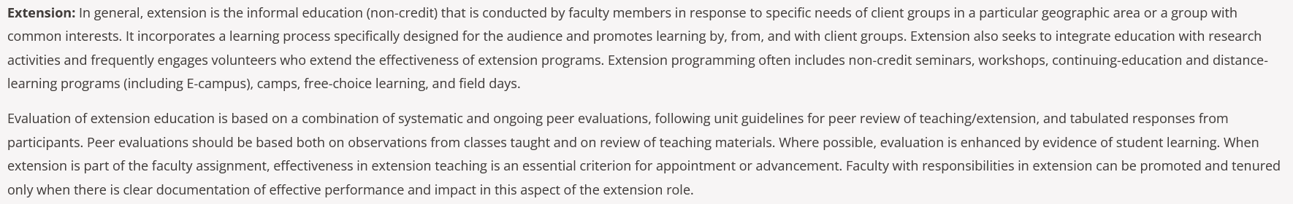
Extension: In general, extension is the informal education (non-credit) that is conducted by faculty members in response to specific needs of client groups in a particular geographic area or a group with common interests. It incorporates a learning process specifically designed for the audience and promotes learning by, from, and with client groups. Extension also seeks to integrate education with research activities and frequently engages volunteers who extend the effectiveness of extension programs. Extension non-credit education occurs in many formats, including seminars, workshops, continuing-education courses, online learning environments, camps, self-directed learning, and field days. It may be delivered to large or small groups, in one-on-one consultations, or through educational resources and materials.
When extension is part of the faculty assignment, effectiveness in extension teaching is an essential criterion for appointment or advancement. Faculty with responsibilities in extension can be promoted and tenured only when there is clear documentation of effective performance and impact in this aspect of the extension role.

Evaluation of extension non-credit education is based on a combination of systematic and ongoing mechanisms, including: (1) peer review of teaching evaluations, following unit guidelines (2) tabulated responses from adult learners or participants represented through the Community Learning Experience (CLE) survey responses; (3) a reflective statement contextualizing one’s teaching; and (4) supplemental evidence of participant learning (knowledge, attitudes, behaviors, skills) and/or changes in broader conditions.
- Peer review of teaching evaluations should apply relevant principles and sub-principles of the Quality Teaching Framework to a) observations of educational programming and/or learning management system content (as relevant to teaching modality) and b) review of learning materials. Where possible, evaluation is enhanced by evidence of student learning. Candidates should follow unit guidelines for peer review of teaching evaluations consistent with evidence-based practices. Guidance and resources for peer review of teaching evaluations are also provided by the Center for Teaching and Learning (CTL).
- The Community Learning Experience survey (CLE) collects participant feedback aligned with extension-specific principles of the Quality Teaching Framework in a brief survey of program participants. The CLE will be collected from a portion of program participants based on the faculty member’s FTE assignment for extension teaching and in accordance with unit guidelines. CLE surveys will be administered in accordance with unit guidelines. Extension educators will be exempted from administering Community Learning Experience (CLE) surveys to youth participants (age<18); in such cases, supplemental evidence may be provided in place of the CLE. While data from the CLEs should be included in a candidate’s dossier, data from the CLEs should not be used for comparison of faculty. Candidates should include a summary table (see example below).

Survey Administration Date or Date Range | Program Name | Sample (# of responses) | Overall Score

- Candidates may provide supplemental evidence of instruction gathered via alternative approaches and methods that align with best-practices in community-engaged teaching, such as aggregated findings from supplemental data collection activities and data from non-participants (e.g., volunteers, parents of youth participants, community partners, etc). Supplemental evidence should be summarized briefly (2-pages maximum, single-spaced, 12-point font, one-inch margins), should be written by the candidate and should contextualize source(s) of supplemental evidence.
- Candidates may, if they choose, include a reflective statement that provides additional context for the evaluation of their instruction. The statement should be brief (one-page maximum, single-spaced, 12-point font, one-inch margins), should be written by the candidate, and should contextualize and augment other forms of teaching evidence in the dossier (i.e., peer review of teaching evaluations, CLE survey responses, supplemental evidence, and the candidate statement). The statement may draw from quantitative and qualitative data, providing an opportunity for candidates to situate evidence within a broader context. When applicable, the reflective statement may explain efforts the candidate is making to improve or enhance the effectiveness of their teaching and participants’ learning. Examples of these efforts include, but are not limited to, pedagogical professional development, changes to program design or materials, incorporating inclusive learning practices, conducting scholarly inquiries into one’s teaching, etc.

